**Abstract**

Vehicles in the present day are more automated to allow human drivers to relax while driving. In this project we have tried to implement a prototype version of self driving cars which tries to

mock the same functionality but on a budget and at a smaller scale. The following vehicle will follow a targeted path automatically avoiding any obstacles that come on it’s way. The car achieves this using a mounted camera and sensory information in real-time. All the computation happens on a remote server/workstation because of the computational limitations on small microcontrollers. The project leverages quite a few computation and communication techniques including remote streaming real time visual and sensory data wirelessly, training and inferring on Convolutional Neural Networks, feedback loops using PID algorithms, gamified interface for controlling the car during a training phase, and much more. Automated driving amid a large traffic jam is a real-life use for a human-scalable version of this idea, relieving the driver from constantly stopping or accelerating. The idea is heavily inspired by the rise of intelligent machines and automation of tedious human tasks.

***Key words*:** self driving cars, Neural Networks, Arduino Uno, Raspberry Pi, Master, Slave

**Contents**

|  |  |  |  |  |  |
| --- | --- | --- | --- | --- | --- |
| **Nomenclature**…………………………………………………………………………....... | | | | | X |
| **1** | **Introduction**……………………………………………………………………... | | | | 1 |
|  | 1.1 | | Background……...……………………………………………………….. | | 1 |
|  | 1.2 | | Motivation ……………………………………………………………….. | | 2 |
|  | 1.3 | | Scope of the project …………………………………………………….. | | 4 |
|  | 1.4 | | Brief description of project undertaken…………………………………. | | 6 |
| **2** | **Literature Survey**………………………………………………………………. | | | | 8 |
| **3** | **Project design** ………………………………………………………………… | | | | 14 |
|  | 3.1 | | | Introduction………………………………………………………………. | 14 |
|  | 3.2 | | | Problem statement………………………………………………………… | 14 |
|  | 3.3 | | | Block diagram / system diagram…………………………………………. | 15 |
|  | 3.4 | | | Flow chart | 16 |
|  | 3.5 | | | System Architecture | 17 |
|  | 3.6 | | | Tools and Technologies | 17 |
|  | 3.6.1 | | | Hardware | 18 |
|  | 3.6.1.1 | | | L298 H Bridge | 19 |
|  | 3.6.1.2 | | | Arduino Uno | 21 |
|  | 3.6.1.3 | | | Raspberry Pi | 24 |
|  | 3.6.1.4 | | | 4 Channel Rc Car | 26 |
|  | 3.6.1.5 | | | Pi Camera | 27 |
|  | 3.6.1.6 | | | Props Used | 28 |
|  | 3.6.2 | | | Software | 29 |
|  | 3.6.2.1 | | | Arduino IDE | 29 |
|  | 3.6.2.2 | | | Embedded C | 29 |
|  | 3.6.2.3 | | | Neural Network | 30 |
|  | 3.6.2.4 | | | Open CV | 33 |
|  | 3.7 | | | Objectives | 36 |
| **4** | **Implementation and experimentation….**……………………………………. | | | | 37 |
|  | 4.1 Workstation Selection | | | | 37 |
|  | 4.2 Stop Sign Detection | | | | 38 |
|  | 4.3 Lane Detection | | | | 40 |
|  | 4.4 Object Distance calculation | | | | 41 |
| **5** | **Conclusions and scope for further work**…….……………………………… | | | | 43 |
|  | 5.1 | Conclusions………………………………………………………………. | | | 43 |
|  | 5.2 | Scope for further work……………………………………………………. | | | 44 |
| **Bibliography** ……………………………………………………………………………... | | | | | 49 |
| **Acknowledgement** ……………..………………………………………………………... | | | | | 52 |

**List of Figures**

|  |  |  |
| --- | --- | --- |
| 1.1 | IOT pic art | 1 |
| 1.2 | Multiple self-driving cars | 2 |
| 1.3 | Technologies required in a Self Driving car | 4 |
| 1.4 | Project Model | 6 |
| 2.1 | Self driving car pic art | 8 |
| 2.2 | General motor self driving car expedition | 9 |
| 2.3 | Crash of self driving car | 10 |
| 3.1 | Block diagram | 15 |
| 3.2 | Flow Chart for lane detection | 16 |
| 3.3 | System Architecture | 17 |
| 3.4 | Block Diagram of L298 H BRIDGE | 19 |
| 3.5 | Connection Overview of L298 H BRIDGE | 20 |
| 3.6 | Circuit Connections Overview between Arduino Uno and L298H BRIDGE | 21 |
| 3.7 | PIN OUT Diagram of Arduino Uno | 22 |
| 3.8 | Connection Overview between Arduino Uno and Raspberry Pi | 24 |
| 3.9 | RASPBERRY Pi pin out Diagram | 25 |
| 3.10 | 4 Channel RC CAR | 27 |
| 3.11 | Raspberry Pi Cam | 27 |
| 3.12 | Props | 28 |
| 3.13 | Arduino IDE | 29 |
| 3.14 | Deep Net | 30 |
| 3.15 | Activation Functions | 32 |
| 3.16 | Neural Network | 33 |
| 3.17 | Region of interest | 34 |
| 3.18 | Perspective warp | 35 |
| 3.19 | Canny edge detection | 36 |
| 4.1 | Comparison between Plans | 37 |
| 4.2 | Object detection using image recognition | 39 |
| 4.3 | Lane detection using Open CV | 40 |
| 4.4 | Stop Sign Distance Calculation | 41,42 |
| 5.1 | Tesla Mode x | 45 |
| 5.2 | How Tesla Model uses artificial intelligence | 45 |
| 5.3 | Graph of how much India wants autonomous car | 46 |

**List of Table**

|  |  |  |
| --- | --- | --- |
| 3.1 | Tools Used | 17 |
| 3.2 | Technologies Used | 18 |
| 3.3 | Specifications L298 H Bridge | 19 |
| 3.4 | Specifications Arduino UNO | 21,22 |
| 4.1 | Plan A VS Plan B | 38 |

**CHAPTER 1**

**Introduction**

The chapter presents a brief overview of the various projects undertaken, why we choose to undertake such a project and the scope of self driving cars in India. It also gives an overview of the project that we have undertaken.

* 1. **Background**

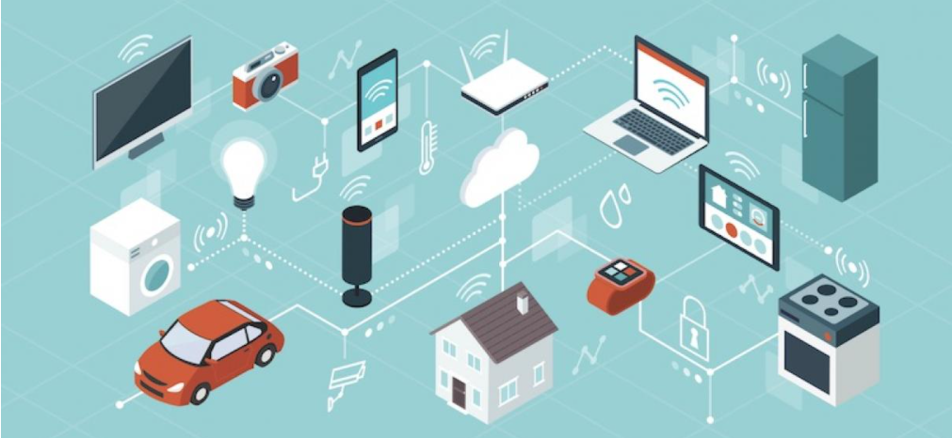

**Figure 1.1 IOT Pic Art [1]**

The Internet of Things (IoT) is a connection of physical objects, such as gadgets, cars, buildings, and other items, that are equipped with electronics, software, ultrasonic sensors, and network connectivity to gather and share data. IoT is a term that describes a collection of things/objects that may be connected via wireless and wired connections in order to communicate with one another. Because we are linking numerous chips, output devices, and other devices, our notion of constructing a smart car is also based on IOT, where we will also apply certain Machine Learning Techniques (Deep Learning).

Keeping the safety of people and the traffic in hand ,our aim is to create a prototype of self-driving car since, it is the future of the automobile industry. Our project will make necessary prediction e.g. when to shot, when to turn etc. based on some training data.

* 1. **Motivation**

With the rapid growth in number of automobiles, driving one is quite a big challenge now days. This has led to increase in number of accidents, daily travelling time etc. A self-driving car is the ultimate solution to this. The application of self-driving car is not just limited to preventing accidents but could also be used as autonomous vehicles, could lead in drop of harmful emissions up to 60%, improve fuel economy, 40% reduction in travel time, increase lane capacity, eliminate stop and go traffic waves etc. To create a self-driving car we need an immense amount of data to feed to our machine learning model, hence we have decided to create a prototype of a self-driving car and thus understand the basic principles of a self-driving car.

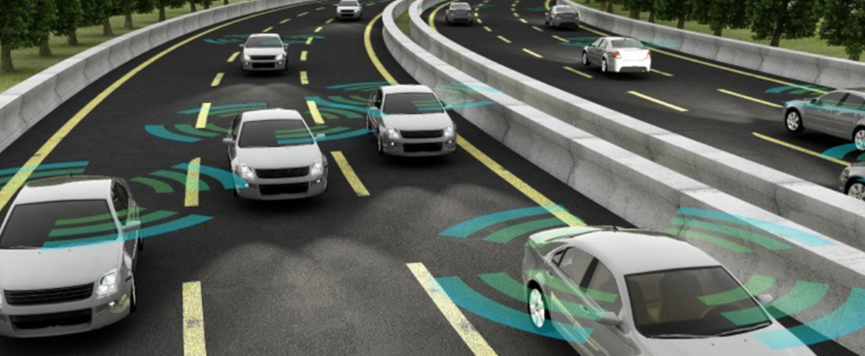

**Figure 1.2 Multiple Self Driving Cars [2]**

Keeping this thing in consideration , here are 5 reasons to embrace self-driving cars:-

1. **Roads Will Become Safer-**

It’s tough initially to wrap our minds round the incontrovertible fact that a car operated by computers could somehow be safer, but consider it this way: what percentage car accidents are caused by some kind of human error, be it speeding, driving recklessly, inattentiveness, or worse, impaired driving? seems that an awesome majority of accidents are caused by humans. In fact, a study by the National Highway Traffic Safety Administration (NHTSA) revealed that 94% of accidents were caused by the drivers themselves.  
  
Self-driving cars, on the opposite hand, are purely analytical, wishing on cameras, radar, and other sensors to navigate. There’s no emotion involved, and definitely no distractions like cell phones or impairing factors like alcohol to affect driving performance. The computers in a very smart car simply react quicker than our minds can and aren’t at risk of the numerous potential mistakes we will make on the road. As a result, a future stuffed with self-driving cars are going to be a safer one.

1. **Humans Will Become More Productive-**

While many people travel through public buses or trains, but some crowd still prefer to travel through their own vehicles. A driverless car gives them the comfort to sleep while car will help them to reach to their destination. They can also utilize the time during the trip.

1. **One Can Save Money-**

As self-driving cars are safer, they will reduce the number of accidents and the expenses related to that, implying that insurance prices will not rise as well. Furthermore, self-driving automobiles do not experience the same level of wear and tear as no unskilled driver drives it. Unless an emergency is identified, they don't floor the treadle or smash the brakes, resulting in better upkeep, less depreciation, and even higher fuel economy. These little costs may rapidly pile up, thus self-driving cars being more expensive up front, can readily pay for themselves in the long run.

1. **Friendly To Environment-**

Self-driving automobiles have the potential to be extremely beneficial to the environment. According to the Union of Scientists, transportation was responsible for more than half of the carbon monoxide gas and pollutant pollution, as well as one-quarter of the hydrocarbons discharged into our atmosphere. While many driverless cars may still release harmful pollutants, their increased efficiency would be a huge step toward a cleaner future.

* 1. **Scope of the project [3]**

The scope of the project isn't limited to small scale RC cars; the car meant to demonstrate the way technology has progressed but at the identical time also demonstrate the essential principles. Autonomous vehicles have been developed by world leaders in the automotive sector. Almost every second manufacturer has developed its own model.Modern day autonomous cars are equipped with hardware for advanced computation and TPUs which offer immediate access to real time input file from advanced sensors within the car. The pc hardware used is capable of processing and inferring multiple deep neural networks simultaneously, this permits the car to use various object detection and regression techniques to further improve the ultimate accuracy of self driven cars. During this project we could also be limited by the hardware capabilities, the microcontrollers we are using won't provide enough computational power to process real time input at high FPS but the industry isn't limited.

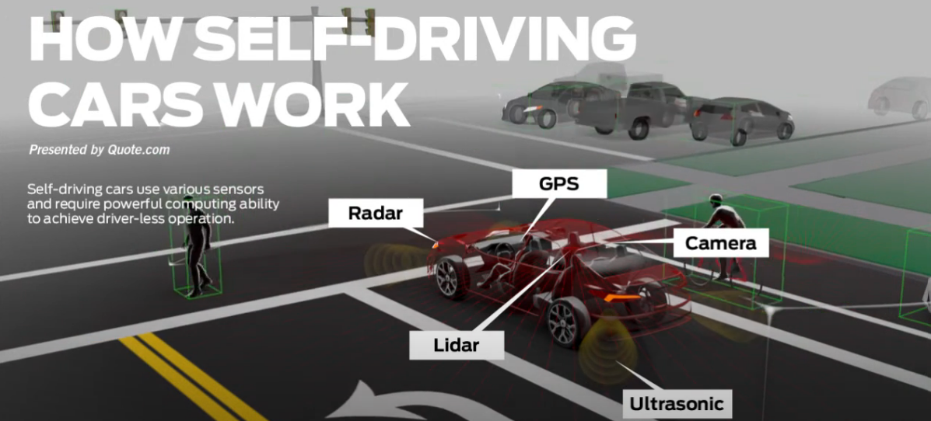

**Figure 1.3 Technologies required in a Self Driving car [4]**

**The scope of Self-Driving cars in India:**  
The technology is still in its infancy. In comparison to roads in Western countries, Indian roads are slightly more tough. Traffic jams are common on Indian roadways, which are notorious for being crowded. The number of traffic accidents and deaths as a result of them is rapidly increasing. These are the few primary issues where autonomous cars can make a significant difference. With the rapid rise of the Internet of Things, it's reasonable to say that it will pave the road for self-driving cars. Ola is one of several companies in India exploring with aspects of autonomous vehicle technology. Many startups have arrived who have heavily invested in this technology.

Some self-driving technology projects that have come up in India are:

• FLUX AUTO  
• ATIMOTORS  
• NETRADYNE  
• FISHEYEBOX.

**India must overcome a number of obstacles before self-driving vehicles can be introduced into the country.**

In India, the adoption of self-driving automobiles is still a long way off. The following are some of the reasons:

* The Indian government has taken a firm stance against the introduction of self-driving cars in the country, citing job loss as the primary reason. According to the government, there are 40 lakh drivers in the country, with a shortage of 25 lakh. The government does not want to jeopardize trained driver positions, claiming that the implementation of this technology might jeopardize the jobs of approximately a crore people. Furthermore, the government feels that the infrastructure necessary for such a technology—complete with well-organized driving conditions—is currently lacking in the country.
* When compared to their western equivalents, India's highways are not suited to self-driving automobiles. Cities like Delhi and Mumbai have roadways that are always congested at all hours of the day. Furthermore, Indian drivers disregard traffic laws. They ignore the signals and drive in the wrong lane. This is a dangerous driving behavior that a driverless car is not taught to anticipate!
* There are concerns about the economic feasibility of deploying self-driving vehicles in India, since corporations are concerned about high R&D expenditures and market viability.
* To make matters worse, India was placed 24th out of 25 nations in KPMG's Autonomous Car Readiness Index 2019 when it came to self-driving vehicle readiness.
  1. **Brief description of project undertaken**

**OVERVIEW**

A self-driving automobile, also known as an autonomous vehicle, driverless car, or robotica vehicle, is one that can sense its surroundings and move safely with little or no human interventionWith every young generation of automobiles, more autonomous systems and collision avoidance technologies are included. Blind-spot monitoring, forward-collision warnings, and lane-departure warnings are already available on many high-end and mid-priced vehicles today. These are the components of completely autonomous cars of the future because the majority of automotive accidents are caused by human error, removing control of the moving vehicle from the driver is expected to dramatically reduce highway deaths.

**PROJECT MODEL**

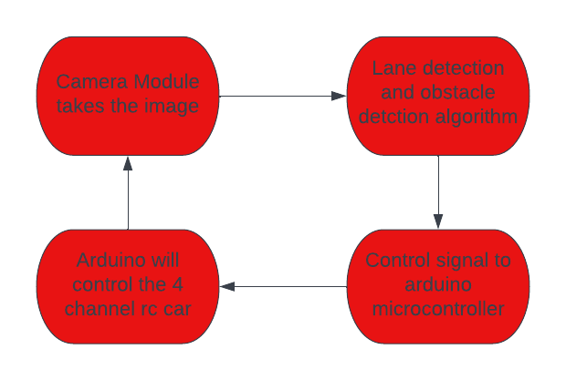

**Figure 1.4 Project Model**

**How do Driverless cars work?**

Autonomous automobiles rely on sensors, actuators, advanced algorithms, artificial intelligence systems, and super computers for the purpose of execution of such softwares . For the successful working of autonomous vehicles    sensors, processors, and other components of the vehicle must be configured properly such that there is a strong communication pipeline between all of them. A proximity sensor usually keeps track of surrounding obstructions. Traffic lights, road signs, other cars, and pedestrians are all detected by video cameras. Lidar sensors detect road edges, detect road borders, and recognize lane lines by bouncing sunlight pulses.

After processing all of this sensory data, advanced software traces the path and delivers commands to the car's actuators, which control acceleration, steering, and braking. The programme follows traffic regulations and navigates obstacles thanks to hard-coded rules, obstacle avoidance algorithms, predictive modelling, and visual perception.

**OBJECTIVES**

• Basic ground is to spot obstacles within the path

• Configure the functionalities of Raspberry PI, USB camera, Ultrasonic sensor and Arduino

• Applying various image processing techniques using opencv library and machine learning

algorithms to form results accurate.

**TARGET AUDIENCE**

* Public Transport companies - can help drivers save money
* Car Vendors - For differently Abled, too old to drive market
* Courier Services -DTC, Fed X
* Heavy Good Shipping companies

**Chapter 2.**

**Literature Survey**

This chapter explains the need of self driving car and throws light on various studies that had been done before and are being used as a reference to build our project.

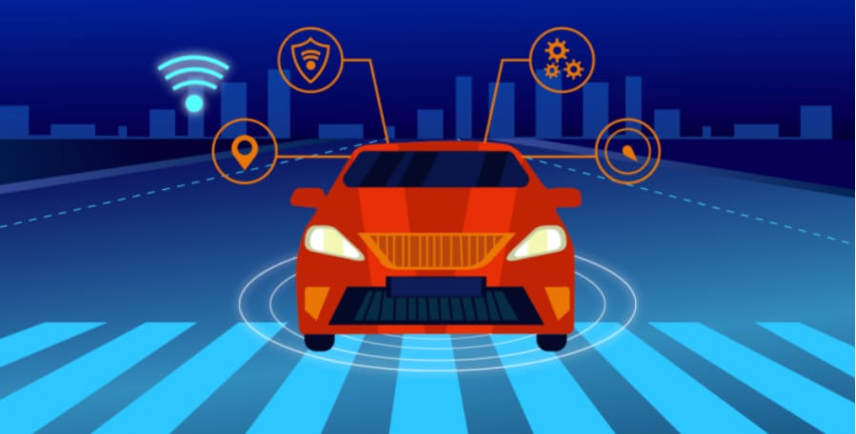

**Figure 2.1 Self driving car pic art [5]**

**Why Driverless Cars!**

Traditional automobiles need the presence of a driver. A good driver must know and recall all driving regulations, be physically and mentally fit, and so on, and the possibilities of making an error are quite high even if all of these prerequisites are met. Self-driving cars have the potential to be a game changer in terms of road safety, social inclusion, pollution, and traffic congestion. The concept of a self-driving automobile dates back over a century. Experiments on self-driving automobiles have been going on since the 1920s, encouraging testing took performed in the 1950s, and development has continued since then. With Carnegie Mellon University's Navlab and ALV projects in 1984 and Mercedes-Benz and Bundeswehr University Munich's Eureka Prometheus Project in 1987 **[6]**, the first self-sufficient and totally autonomous automobiles arrived in the 1980s. Currently, the world's largest automotive manufacturers are pouring billions of dollars in autonomous vehicle research. The advantages of completely autonomous cars may extend well beyond the elimination of the requirement for a human driver. Self-driving cars might eventually replace human drivers in transportation services, making them a less expensive and better option for end users than owning a car. This, in turn, will aid in the reduction of pollution, traffic congestion, social costs, and time savings, since individuals will no longer be reliant on others to take them to a location, particularly in the case of small children, and this may lead to a relaxation of traffic laws.

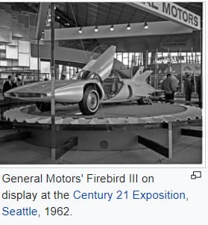

**Figure 2.2 General motor Self Driving car expedition [7]**

However, it is incorrect to believe that self-driving automobiles are totally safe. There are still certain security flaws, such as the danger of hacking, incorrect projections, etc., individuals may lose their jobs, and the initial cost of production is too expensive. A half-dozen individuals have died as a result of deadly accidents caused by malfunctioning autonomous vehicles thus far. Another issue in this sector is the absence of technology for optimum data exchange between autonomous components inside the driverless car as well as between driverless automobiles. For navigation and collision avoidance, autonomous cars rely significantly on technology such as LIDAR, GPS, high-definition mapping, and artificial intelligence.**[8]**

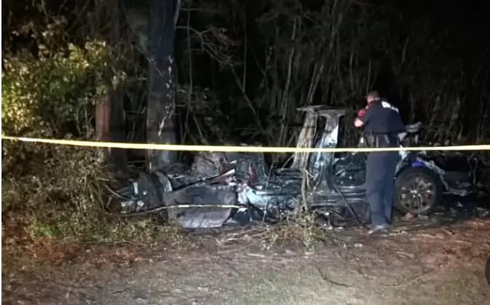

**Figure 2.3 Crash Of a Self Driving car [9]**

If in future we successfully create scalable driverless cars, issues like-

* emergency lane changes
* early obstacle avoidance
* temporary stops
* pile-up avoidance **[9]**

Could be readily cared for without the need for human intervention. It is undeniably true that they are not yet safe or scalable, and that much more study is required, but dismissing the concept is entirely incorrect.

**CAMERA PLACEMENT**

The camera is placed at back of the car at a height 0.5 meters from the ground in driving car, at an angle to see the path at 0.5m without having a blind spot on the lane. The camera captures 1280x720 at 24 frames per second in RGB format. Then video is sent to the model designed for image processing. **[10]**

**HYSTERRIS PROCESS AND CANNY EDGE DETECTION**

Finally, multiple phases of edge identification were investigated, and algorithms were developed. A variety of kernels were compared. Non-maximal suppression and hysteresis were examined as well as their advantages. Edge direction and gaussian pyramids were used to try out more complex kinds of hysteresis. Based on thresholding and standard deviation values, the strategies are mostly user-defined. These settings can be modified for each image to achieve a satisfactory reaction. These human criteria would be bypassed by a more rigorous approach. [**11]**

Chun-Che Wang, Shih-Shinh Huang, LiChen Fu, and Pei-Yung Hsiao's **[12]** study attempts to enhance driving by developing a system of help. The programme combines lane detection and a vehicle identification technology to improve driver safety at night. Lane detection aids in the localization of markers so that the lane can be identified, whereas vehicle recognition entails the extraction of taillights and the use of a taillight paring technique. Another study **[13]** by Xiaodong Miao, Shunming Li, and Huan Shen used models to determine road lane locations in real-time. To extract an edge map, a canny edge extraction operation is used, followed by a matching approach and the selection of probable edge locations. Finally, the lane lines are linked to localise them. The goal of **[14]** by Anik Saha, Dipanjan Das Roy, Tauhidul Alam, and Kaushik Deb is to transform a picture from RGB to grayscale. The related components were then labelled using a flood-filling technique. Then the lane, which is the largest linked component, is removed. In order to construct a prototype of an autonomous automobile, Gurjashan Singh Panna, Mohammad Dawud Ansari, and Pritha Gupta **[15]** suggest using a lane detection algorithm as well as obstacle detection. Their research intends to create a monocular vision autonomous automobile prototype capable of safely arriving at a certain location. Another work model presented by R.Mohanapriya, L.K.Hema, Dipeshwarkumar Yadav, and Vivek Kumar Verma **[16]** and Ms. D.D Jadhav, Komal Jadhav, Kajal Shinde, and Anjali Sonawane **[17]** involves equipping a four-wheeled robot with a GPS and GSM system. The robot is guided by the GPS system, which allows it to go from one location to another without the need for human involvement. In the former, they agree to notify theft if it occurs via a GSM system. The vehicle owner receives a SMS alert informing them of the problem, and as a consequence, they can turn off the ignition. In the latter case, the project stipulates that the vehicle can only be switched on if an authorised person transmits a preset location to the car. Dhanasingaraja R, Kalaimagal S, and Muralidharan G created a system in **[18]** that takes the user's present location and calculates their destination. The algorithm then calculates the quickest path to the target and collects information from the graph such as latitude and longitude. In a nutshell, it aids navigation as well as vehicle monitoring.

They have proposed an autonomous automobile platform based on the softmax function, which squashes the outputs of each unit to be between 0 and 1, comparable to a sigmoid function, in literature **[19].** The softmax function ranges the output like a sigmoid function, although a genuine softmax function does not. The use of a neural network allows for real-time output. They tested the model on the MATLAB simulator before putting it into practice. Regardless of whether lane markers are present or not, the system employs only one camera for all inputs and drives at roughly 5-6 km/hr. Only lane markings and turn signs are detected by this model. It just moves the automobile left or right without detecting signals or stop sign.

They have created an autonomous RC car that employs an Artificial Neural Network (ANN) for control in the literature **[20]**. It discusses the neural network and autonomous car theories. An automobile is built using an L298N IC and a motor driver that can be controlled by a microcontroller and then sent back to the model car. The use of CNN aids in the recognition of grey scale components exclusively, while ignoring irrelevant data. The system's capabilities are restricted, but it is accurate. Input is provided through an embedded Pi camera, and pictures are grayscaled for neural network training. The device just identifies lane markers in each direction and does not provide any additional capabilities.

They have described a reinforcement-learning based strategy using Deep Q Network applied in autonomous driving in the literature **[21]**. Objects at a great distance can be detected with lidar sensors. The entire system is built on a simulator that simulates real-world highways and city streets with traffic. The use of a camera and lidar in combination allows for a better understanding of the environment and all types of barriers. They created a model that uses a lidar (laser sensor), which is a highly expensive sensor that may be used in big size autos.

The art of making decisions (left, right, advance, or halt) was solely dependent on Image Processing techniques in the models listed above, while some of them relied on GPS systems to take action. The research proposes a novel model that incorporates Machine Learning and Image Processing, based on all of the previous work and after comprehensive analysis and investigation. The input image is prepared with the assistance of image processing. The image has been resized and Grey scaled. The picture is put into the Convolutional Neural Network after it is finished. The Neural Network's output aids in making directed decisions. After that, the controller just transmits the appropriate signal, and the automobile goes in that direction. The suggested approach uses a Pi cam attached to a Raspberry Pi in the automobile to capture a picture. The Raspberry Pi and the laptop a both are connected to the same network, and the Raspberry Pi delivers the picture collected to the Convolutional Neural Network as the input image. Before transferring the picture to the Neural Network, it is gray-scaled. The model predicts one of four possible outcomes: left, right, forward, or halt. When the outcome is anticipated, the relevant Arduino signal is activated, allowing the automobile to proceed in a certain direction using its controller.

**Chapter 3**

**Project Design**

This chapter is an exact summary of the project we have done. It explains the various components and technologies which have been used and how they have been configured for the successful working of this project.

**3.1 Introduction**

Self-driving vehicles are a hot topic these days, and with good reason. They might usher in the largest societal change since the industrial revolution, and it looks like everyone is in on it. Driverless cars have the potential to solve a wide variety of issues, including traffic jams and accidents caused by driver error, but that's not all as autonomous vehicles will bring a wide range of new and exciting applications for a variety of industries, which includes shipping, transportation, and emergency services .Yet there is a lot to explore in the field of Self Driving cars and how they'll impact the automotive industry in the future. Hence, our project aims to give a brief overview of one of the ways how self driving cars are being developed by modern companies by developing a prototype. The project will involve a 4 wheel drive RC car modified by adding external hardware peripherals like camera, to convey information related to the car's surroundings to a ground station. The car is also always connected to a computer for computation wirelessly. It will navigates through a labeled path which it has been trained on, avoiding any obstacles it may encounter during its course.

**3.2 Problem Statement**

Design a prototype version of self driving car that can follow a particular lane , can also change lane when it’s completed , follows various traffic signals and other collision objects to safely reach its destination utilizing different image processing and artificial intelligence approaches.

**3.3 Block Diagram**

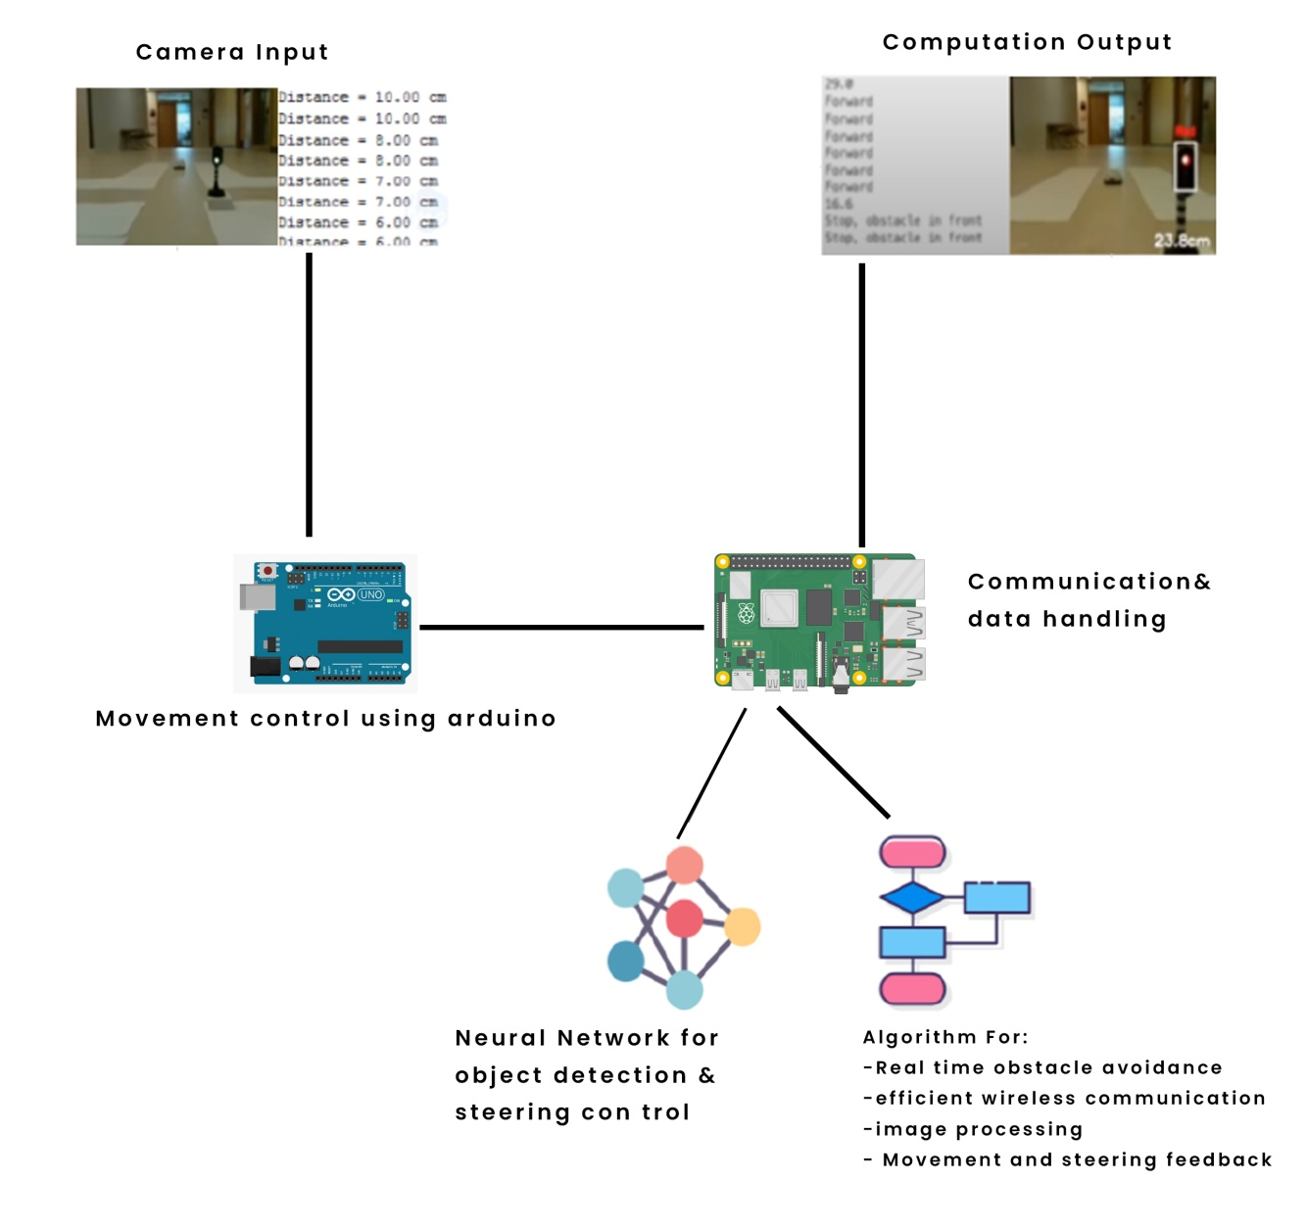

**Figure 3.1 Block Diagram**

The above diagram gives a basic overview of all the functionalities involved in the project, the basic mechanism is as follows –

* Raspberry PI microcontroller grabs input from the camera
* A deep learning model inside Raspberry Pi sends the predictions for identifying stop signs, traffic lights etc. and steering prediction using Open CV .The model will be trained on labeled data containing various scenarios.
* Based on the predictions Raspberry Pi commands Arduino Uno and Arduino Uno commands the L298 H bridge .
* The data communication between Arduino Uno and Raspberry Pi is done via digital pins of Raspberry Pi and is encoded/decoded according to the defined standards.

**3.4 Flow Chart**

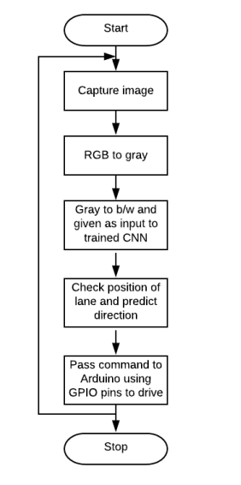

**Figure 3.2 Flow Chart for lane detection**

**3.5 System Architecture**

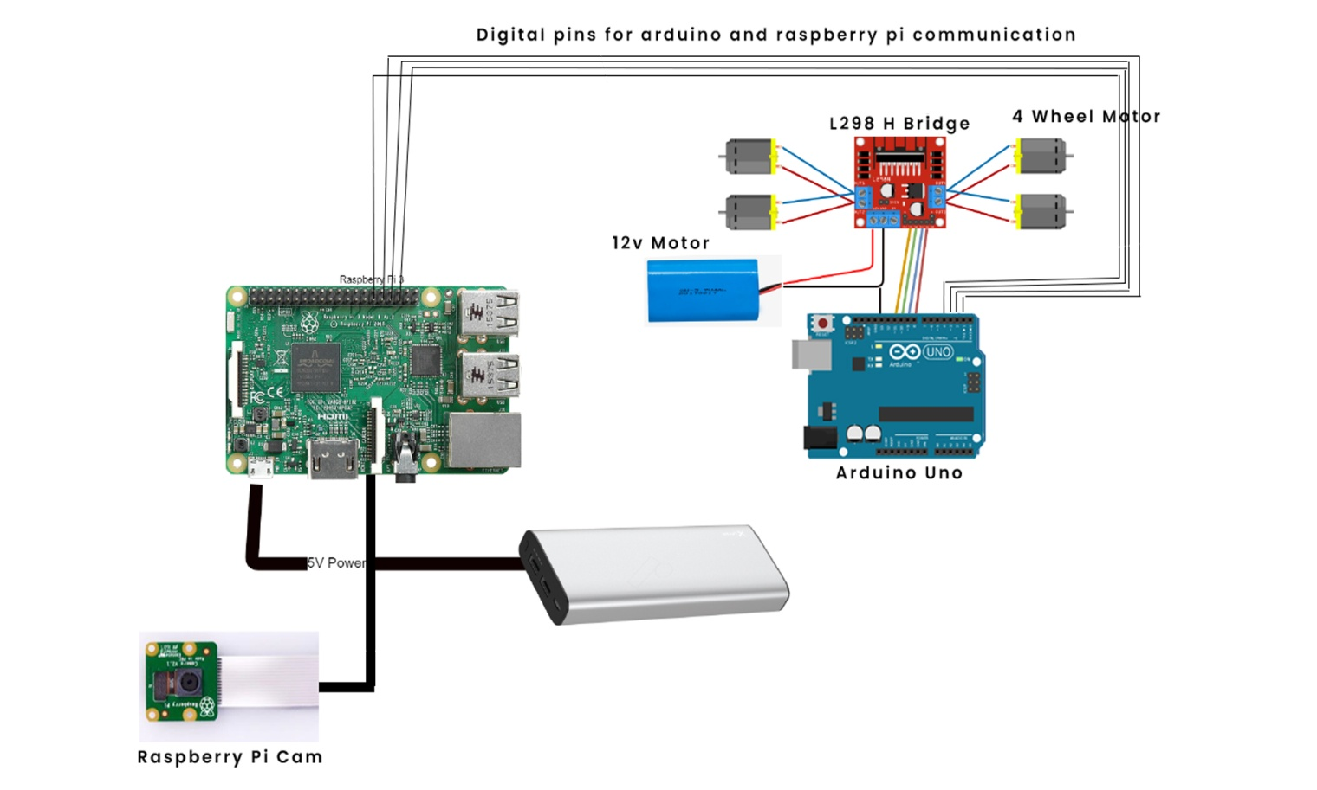

**Figure 3.3 System Architecture**

**3.6 Tools and Technologies**

**Table 3.1 Tools Used**

Hardware Purpose

|  |  |
| --- | --- |
| 4 Channel RC Car | It will act as a base of our cars , motors will complete the purpose of motion. |
| L298 H BRIDGE | It will supply output power to motors. |
| Ultrasonic Sensor HC-SR-04 | Detects Obstacles |
| Arduino UNO | Microcontroller to drive Motors |
| Raspberry PI 3 | Main Microcontroller to detects obstacles and directs Arduino Uno. |
| External Props | Path Creation Accessories |
| Workstation Computer | Performs Major Computations |

**Table 3.2 Technologies Used**

Software Purpose

|  |  |
| --- | --- |
| Python | Primary Programming Language used for Machine Learning |
| OpenCV | Image Processing library for all the image related computation |
| Tensor flow | Library for creating and using Machine learning / Deep learning models |
| Embedded C | For Arduino coding and motor control. |

Scientific Libraries

1. numpy
2. sklearn
3. matplotlib
4. pandas
5. pygame

These libraries are basically used for support work, mathematical computations, creating model , displaying information to controlling the car.

**3.6 .1 Hardware**

The aim of our project is to create a prototype of a self-driving car. To create this prototype with a focus of it being cost-effective, we have spared no efforts to use minimum to minimum components as we could to meet the requirements for the success of this project.

**3.6.1.1 L298 H BRIDGE-**

SPECIFICATIONS-

**Table 3.3 Specifications L298 H BRIDGE**

|  |  |
| --- | --- |
| Operational Supply Voltage | 0 V – 46 V |
| Rated Power | 25 W |
| Instantaneous Peak Current | 0 A to 3 A |
| Continuous Working Current | 0A to 2 A |

It is a high voltage and current complete bridge driver that consists of two H Bridges used to drive inductive loads (in our case rotating the DC motors). It incorporates a high-capacity filter capacitor and a freewheeling diode to shelter devices from the reverse current of an inductive load, hence increasing safety.

BLOCK DIAGRAM-

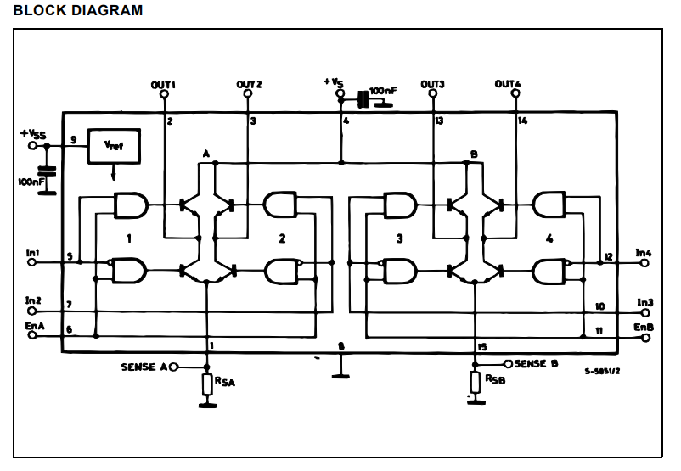

**Figure 3.4 Block Diagram of L298 H BRIDGE [22]**

PURPOSE-

To achieve the successful motion the car we need to control the rotation of all four motors and synchronize the speed of the pair of motors on each side of the car. This could be done via many ways but easiest way is by using a couple of H Bridges.

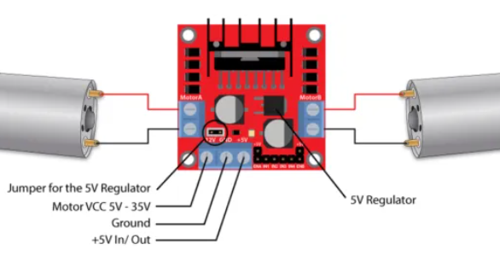

**Figure 3.5 Connection Overview of L298 H BRIDGE [23]**

The L298H-BRIDGE contains two H-Bridge motor drivers that allow for the motion and steering control of two DC motors. As illustrated in fig 3.5, the module contains two  terminal blocks fixed with screws for each motor group i.e. Group A and Group B, as well as three terminal block for the Ground connection, the VCC connection for motor, and a 5V connection that can be an input or output.

To enable the motors we will be using Enable A and Enable B pins and to control the speed we must provide Pulse Width Modulated output to the pins otherwise the motors connected will work at maximum speed. Inputs 1 and 2 control the rotation direction of the motor Group A, whereas inputs 3 and 4 control the rotation direction of the motor Group B.

L298H BRIDGE will be the master of all four motors but will act as a slave to **ARDUINO UNO.** Enable 1, Enable 2, Input 1, Input 2, Input 3and Input 4 pins will receive input from Arduino Uno which could easily be visualized in figure 3.6.

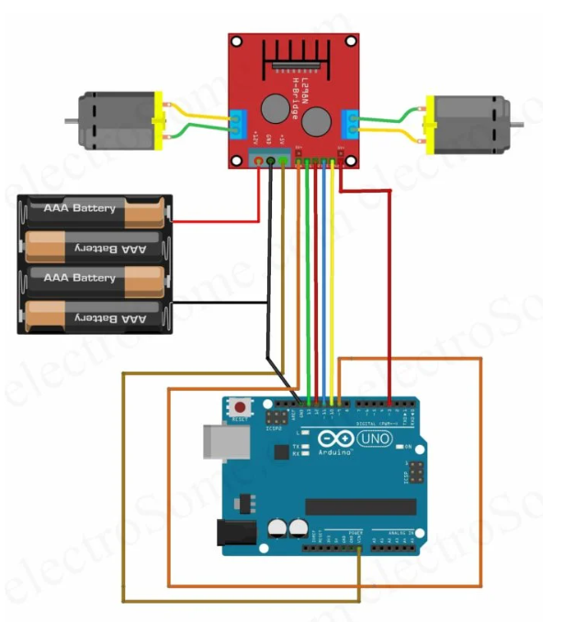

**Figure 3.6 Circuit Connections Overview between Arduino Uno and L298H BRIDGE [24]**

**3.6.1.2 ARDUINO UNO**

SPECIFICATIONS-

**Table 3.4 Specifications Arduino Uno**

|  |  |
| --- | --- |
| Operating Voltage | 5V |
| Input Voltage | 6-20V (Recommended 7-12V) |
| Digital I/O pins | 14 |
| PWN Digital I/O pins | 6 |
| Analog I/O pins | 6 |
| DC current per I/O pin | 20mA |
| Flash Memory | 32KB |
| Clock Speed | 16MHz |

The Arduino Uno is an open source microcontroller board created by Arduino.cc that is based on the Atmege328 microprocessor and is the original Arduino board. For the purpose of writing code, compiling and then embedding it in the board Arduino IDE (Integrated Development Environment) is used.

PIN FUNCTIONS-

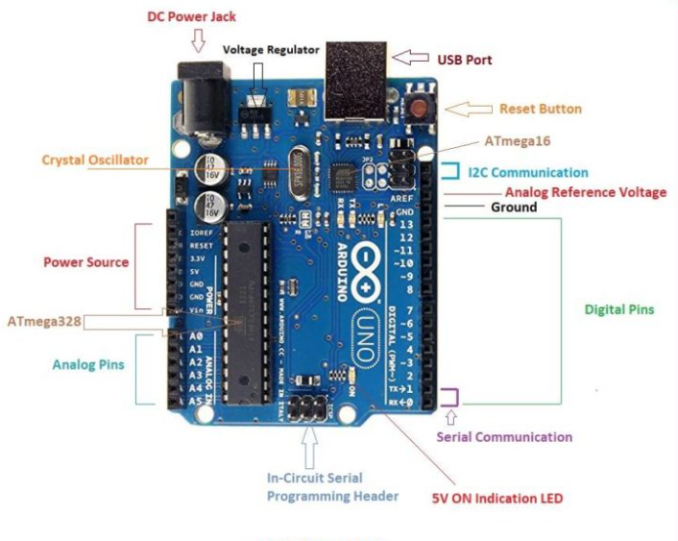

**Figure 3.7 PIN OUT Diagram of Arduino Uno [25]**

**LED**-The is a built-in LED driven by pin 13.

**VIN**: When utilising an external power source, this pin provides the board with a 5 V input voltage (instead of 5 volts from a USB port or another regulated power source). This pin or the power jack can both be used to deliver voltage.

**5V**: This is a pin that receives a regulated 5V from the board's regulator.

**3V3**: The on-board regulator generates a 3.3 v supply and the maximum current drawn is 50 mA.

**GND**: These are typical Ground pins.

**Reset**: It is used to reset the entire board.

Apart from the above general purpose pins there are six analog pins and fourteen digital pins. Both digital and analog pins together provide 20 I/O pins that are controlled using software. Among the digital pins, Pin 11,10,9,6,5 and 3 are PWM pins providing an 8bit PWM output. Serial Pins 0 and 1 are used to receive (Rx) and Transmit (Tx) TTL series data respectively. Pin 2 and 3 are external interrupts The 6 analog pins A0 through A6, each provides a 10 bits of resolution i.e 1024 different value. Pin A4 and A5 are Serial Data Pin (SDA) and Serial Clock Pin (SCL) respectively, both supports Two Wire Interface Communication using wire library.

PURPOSE-

The success of this project depends on the successful role-play by Arduino Uno. It will as a master to the L298H BRIDGE and as well as a slave to the command of Raspberry. The serial pins present will be used to enable the H-Bridges and control the speed of motion of the motors. **Enable A** and **Enable B** pins in L298H BRIDGE are used to turn the motors ON, OFF and control its speed and direction. The Arduino Uno acts to the commands of Raspberry Pi. Basically, Raspberry Pi will periodically call a function in Arduino based on which the Arduino controls the Bridge.

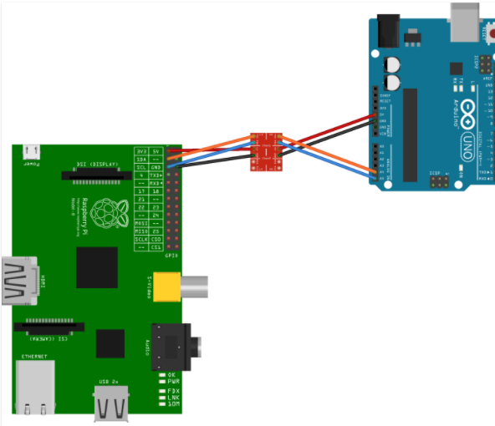

**Figure 3.8 Connection Overview between Arduino Uno and Raspberry Pi [26]**

**3.6.1.3 RASPBERRY PI**

In the realm of IoT, Raspberry Pi is one of the most well-known names. The Raspberry Pi Foundation has created a credit card-sized single board computer (we are using Raspberry Pi 3B).The best way to define Raspberry Pi is to call it “ THE BRAIN ” .The Raspberry Pi board has a Broadcom ARM processor, graphics chip, RAM, GPIO, and various external device ports. The Raspberry Pi works similarly to a PC in that it requires extra hardware such as input devices (keyboard, mouse), output devices (display unit), power supply, and an SD card with an operating system installed (acting as a hard disc) in order to function. Ethernet for Internet/Network-Peer to Peer Connectivity and USB ports are provided to link Raspberry Pi with other devices/boards.

SPECIFICATIONS-

We have used Raspberry Pi 3B in our project. Raspberry Pi is earliest model of 3rd Generation Raspberry Pi. Following is a list of specifications of the model we have used:

* Quad Core 1.2GHz Broadcom BCM2837 64bit CPU
* 1GB RAM
* BCM43438 wireless LAN and Bluetooth Low Energy (BLE) on board
* 40-pin extended GPIO
* 4 Pole stereo output and composite video port
* 4 USB 2 ports
* 100 Base Ethernet.
* Full size HDMI port.
* For connecting a Raspberry Pi cameraCSI camera port is present.
* DSI display port for connecting a Raspberry Pi touchscreen display
* Micro SD port for loading your operating system and storing data(we have used a class 10 64GB SD card)
* Upgraded switched Micro USB power source up to 2.5A

PIN OUT DIAGRAM 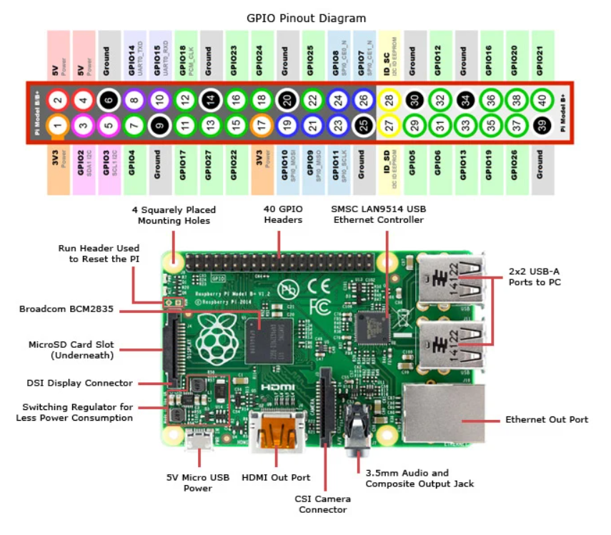

**Figure 3.9 RASPBERRY Pi pin out Diagram [27]**

There are two 5V pins, two 3V3 pins, and nine ground pins (0V) on the board, none of which can be modified. The 5V pins are a direct output and input pin, which means they can power both the Raspberry Pi and other boards. The 3Vpins are used to supply other components with a 3V steady power source. Ground pins function like regular ground pins.

A GPIO pin which acts as an input pin will allow a signal to be received by the Raspberry Pi. Raspberry Pi reads input between 1.8V – 3.3V as high, any input below 1.8V is read as low.

**PWM**- GPIO 12 ,GPIO 13,GPIO 18,GPIO 19 are hardware PWM pins while software PWM is available on all GPIO pins.

**SPI** - Raspberry Pi uses the Serial Peripheral Interface protocol for master slave communication. There are 5 SPI pins in total. Its existence enables the board to communicate swiftly with one or more peripheral devices.

**I2**C- It is used to connect Raspberry Pi to devices that are Inter-Integrated Circuit compliant. Serial Data (SDA) is used to convey data, whereas Serial Clock (SCL) is used to govern data transfer speed.

**UART -**Universal Asynchronous Receiver / Transmitterpins help in communication between two microcontrollers / computers possible. GPIO 14 is Tx pin and GPIO 15 is Rx pin.

PURPOSE-

Raspberry Pi 3B is the heaviest processing unit of the entire project. A Raspberry Cam will be connected to it, which will collect and send data (pictures) to Raspberry Pi. Initially it was planned that Raspberry Pi will pass the pictures to a separate work station that will perform the processing and pass decisions to Raspberry Pi and then it would command Arduinouno. But based on the suggestion of our mentors and thinking practically we entirely shifted the responsibility to Raspberry Pi only.

Hence, signal and sign identification using Machine Learning lane detection etc. and lane detection using Open CV will be performed by Raspberry Pi.

**3.6.1.4 4 CHANNEL RC CAR**

­It acts as the base of the car. It comprises of 4 DC motors which will complete the purpose of motion. We have made the connections such that both motors on each side are synchronized. The direction and speed of motion of motors will be controlled by L298H BRIDGE.

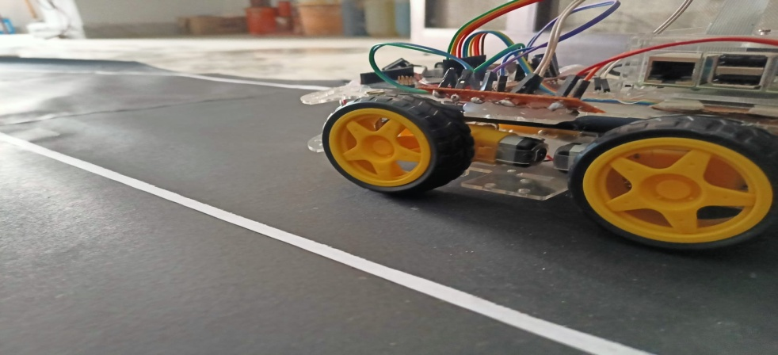

**Figure 3.10 4 Channel RC CAR**

**3.6.1.5 Pi CAMERA**

The Raspberry Pi camera is an excellent tool for capturing time-lapse and slow motion footage in high definition. The camera is 25mm to 24mm by 9mm in size, and it connects to the Raspberry Pi through a flexible elastic wire with a serial interface. The camera image sensor features a five-megapixel resolution and a focused lens. The camera is really useful for security purposes. The camera has several features, including a 5MP sensor, wide image, 2592x1944 stills, and 1080p30 video on the camera module.

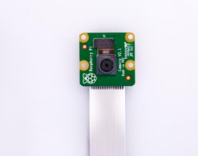

**Figure 3.11 Raspberry Pi Cam**

PURPOSE-

Raspberry Pi Camera will capture video stream of our prototype, which will then be

use both for lane detection and obstacle detection.

**3.6.1.6 Props used**

We have created an artificial environment , the artificial environment has a lane , some traffic sign red , green and a stop sign .

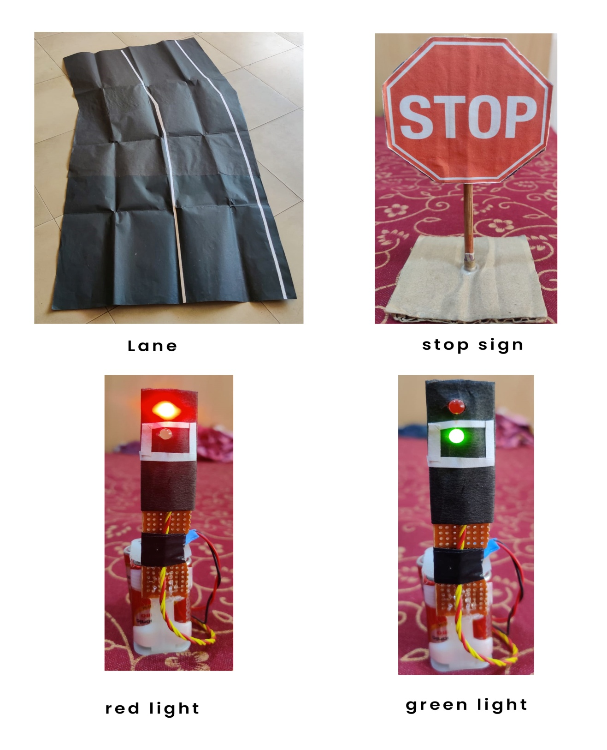

**Figure 3.12 Props**

**3.6 .2 Software**

**3.6.2.1 ARDUINO IDE**

The Ardino IDE is the development environment for Arduino board applications. It has a compile button for assisting with code compilation and an upload tab for assisting with code posting to the board. Sketches are programmes that are written with the Arduino IDE and saved as.ino files. Verify, save, upload, include library, and serial monitor are some of the editor's other features. Aside from that, the creators have provided basic tools that make coding easy and exciting. Each interface also contains a number of examples to help the user understand more about the functionality and hardware.

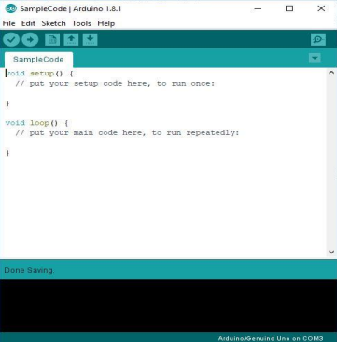

**Figure 3.13 Arduino IDE**

**3.6.2.2 EMBEDDED C**

Embedded C is the most widely used programming language in the software industry for creating electrical devices. Embedded software is coupled with each processor utilised in an electronic system.

Embedded C programming is essential for the CPU to accomplish specified tasks. We utilise a variety of technological equipment in our daily lives, such as a cell phone, a washing machine, a digital camera, and so on. All of these devices are controlled by microcontrollers that are coded in embedded C.

**3.6.2.3 NEURAL NETWORK**

**What is a neural network?**

* A series of algorithms trying to recognize relationships in a set of data
* In simple words it’s a network which is trying to make computer model of the brain
* The main objective of building this network is to perform various complex computational tasks faster
* A neural network works similarly like the human brain’s neural network.

In a neural network, a "neuron" is a function that gathers and categorizes data based on its characteristics. Layers of linked nodes make up a neural network. Each linked node is called perceptron .A perceptron is a type of node that is comparable to a multiple linear regression.

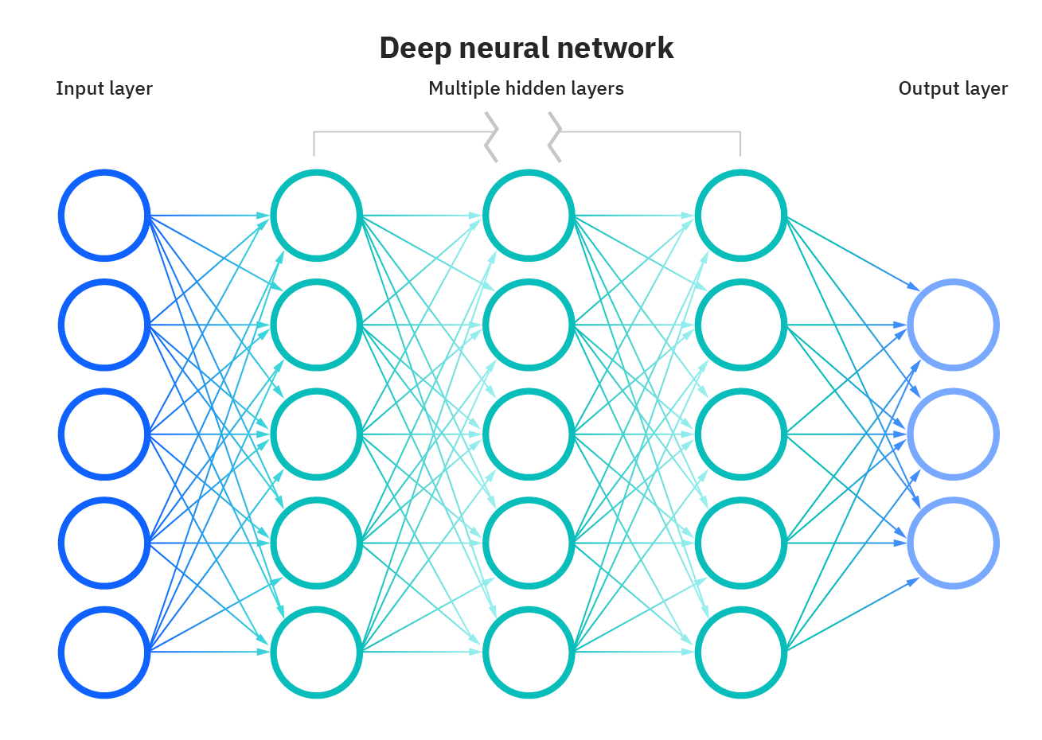

**Figure 3.14 Deep Net [28]**

Node layers in artificial neural networks (ANNs) include an input layer, one or more hidden layers, and an output layer. Each node, or artificial neuron, is connected to the others and has a weight and threshold linked with it. If a node's output exceeds a certain threshold value, the node is activated, and data is sent to the next layer of the network. Otherwise, no data is transmitted forward to the network's next layer.

**Input Layer:**

It takes input in a variety of formats specified by the programmer.

**Hidden Layer:**

Between the input and output layers is a hidden layer. It does all the math to uncover hidden features and patterns.

**Output Layer:**

The hidden layer transforms the input, resulting in output that is communicated through this layer.

The weighted total of the inputs is computed by the artificial neural network, which also incorporates a bias. A transfer function is used to express this calculation.

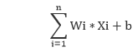

To create an output, the weighted total is supplied as an input to an activation function. Activation functions determine whether or not a node should fire. The output layer only accepts only those who have been fired. There are severas activation functions that may be used depending on the type of work we are doing.

**Activation Function**

Applying an activation function during forward propagation adds an extra step at each layer. Now the point is can we create a model without an activation function if the activation function adds so much ambiguity?

Without an activation function, a neural network is just a simple linear regression model. Although a linear model is very simple, it makes neural networks easier to understand but on the other hand they also make it less strong and unable to learn complicated patterns from input.

Hence we create a non linear model. A non linear model can be created by adding non linearity using different activation functions. An activation function can be same for all the layers or it can be unique for each layer.

Following figure represents some popular activation functions.

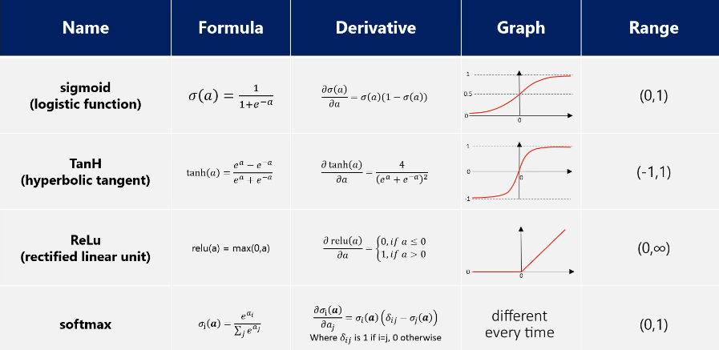

**Figure 3.15 Activation Functions [29]**

**Advantages of Neural Network**

* **Parallel processing capability:** Artificial neural networks have a numerical value that can perform more than one task simultaneously.
* **Storing data on the entire network:** Data that is used in traditional programming is stored on the whole network, not on a database. The disappearance of a couple of pieces of data in one place doesn't prevent the network from working.
* **Capability to work with incomplete knowledge:** After ANN training, the information may produce output even with inadequate data. The loss of performance here relies upon the significance of missing data.

Sign detection will completely done using neural network. Basically we will feed the model with positive and negative images. Positive images will be the images of STOP sign, REDLIGHT etc., while negative images will be the images of track.

We will use an RGB scale (Red Green Blue), each pixel will be represented as a combination of three shades of Red Green Blue i.e. three matrices (Tensor of Degree 3) representing three shades will be created where each shade is represented as a number. These matrices will be input to the model for predictions. **[17]**

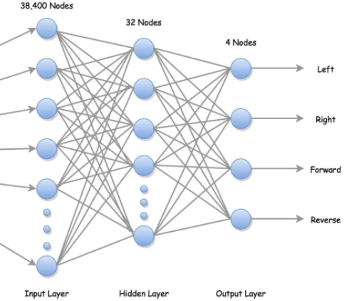

**Figure 3.16 Neural Network [30]**

**3.6.2.4 OPEN CV (IMAGE PROCESSING)**

Open CV is an open source computer vision toolkit that can handle images/videos for various image processing tasks ranging from simple to extremely sophisticated, such as facial recognition. It runs on Windows, Linux, Mac OS, iOS, and Android and supports C++, C, Python, and Java programming languages. The library, which is written in optimised C/C++, may take advantage of multi-core processing. It may take use of the hardware acceleration of the underlying heterogeneous computing platform when enabled with OpenCL [14]. It assists in cropping off a set of images from the Raspberry-Pi cam interface, converting it to grayscale, resizing it, and then passing it to the Convolutional Neural Network in this project.

We used Opencv in our self driving car prototype , OpenCv is a free and open source image processing library , it is also cross platform , also it supports machine learning , we will also try to train our cascade classifier to detect stop sign and traffic lights .

In comparision to tensor flow and keras opencv is not performance extensive , that’s why we are using it in our project.**[19­­­­]**

**Step 1 – Camera Module placement**

We will try to place camera at certain height and at a position so that it cover maximum area of lane.

**Step 2 – Capture Video**

Capturing image in infinite loop will give us video

**Step3 – Frame per second**

**Step4 – Region of Interest**

A region of interest (ROI) is a segment of a picture that you wish to filter or manipulate in some way. Create a binary mask the same size as the picture you wish to analyse. We will select region of interest such that it covers both the lanes and perspective wrap can be easily obtain from it.

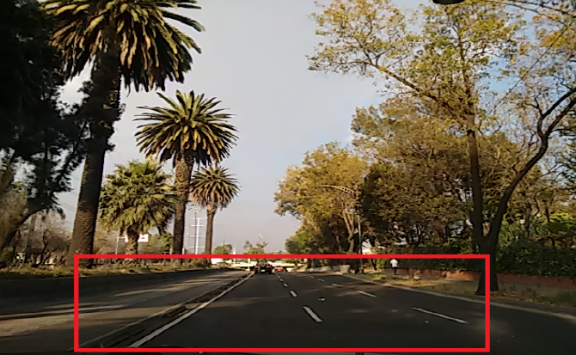

**Figure 3.17 Region of interest [31]**

**Step5 – Perspective Warp**

We may shift the viewpoint of a given image or video using Perspective Transformation to gain greater insights into the needed information. We need to specify the spots on the image from which we wish to obtain information by changing the perspective in Perspective Transformation. We must also supply the points inside which we want our image to be displayed. The perspective transform is then calculated from the two sets of points and wrapped around the original picture. It is like a bird eye view.  
We use cv2.getPerspectiveTransform and then cv2.warpPerspective .

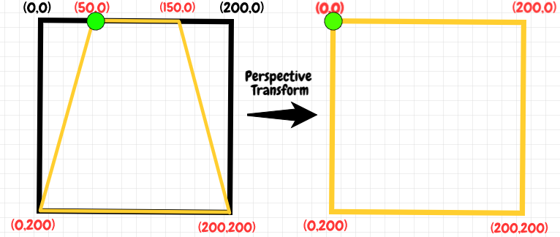

**Figure 3.18 Perspective warp**

**Step6-Canny edge detection**

We use canny edge detection for a variety of edge detection applications, including lane identification, drawing, and border removal.

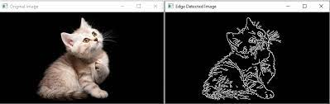

**Figure 3.19 Canny Edge Detection [32]**

**Step7-Histogram Process**

In the histogram process we basically differ pixels on basis of their intensities , white becomes 255 and black becomes 0 . The histogram is a graphical representation of a digital picture used in digital image processing. A graph is a representation of each tonal value as a number of pixels. The picture histogram is now found in digital cameras. They are used by photographers to see the dispersion of tones obtained.

The horizontal axis of a graph represents tonal fluctuations, whereas the vertical axis represents the number of pixels in that specific pixel. The left side of the horizontal axis depicts black and dark parts, the middle represents medium grey hue, and the vertical axis reflects the area's size.

**Step8-Caliberation of lane centre and frame centre**

We will calculate lane center and compare with frame centre which will help car to move left, right, straight

**3.7 Objectives**

The objective of the project is to

* Briefly demonstrate the working of modern self-driving cars.
* Demonstrate advanced machine learning algorithms that use vision input to compute the result using Convolutional Neural Networks.
* Detection of stop sign and signal detection and stopping of car based on it.
* Demonstrate the extent of machine automation we can achieve without any human input.
* Understand how self- driving cars could be manufactured on a large scale.

**CHAPTER 4**

**Implementation and experimentation**

This chapter presents the actual work our team has done in the form of output pictures and results.

The automobile was tested on a variety of track configurations, including straight, curved, and a combination of straight and curved. Image processing is done for lane detection.

Number of positive samples and negative samples were taken for stop sign, traffic light and obstacle detection, a cascade model was created , HAAR Cascade was chosen .

In the standard platform, Haar-like performance is proven to be superior to LBP in terms of accuracy. It has a 96.24 percent accuracy rate compared to LBP's 94.75 percent. Haar-like accuracy is somewhat better than Local binary pattern on the embedded platform, with a hit rate of 93.56 percent vs 92.65 percent for Local binary pattern. The ratio of hit, miss, and false detection rates of the items to be identified is used to get this percentage.

**4.1 Workstation Selection**

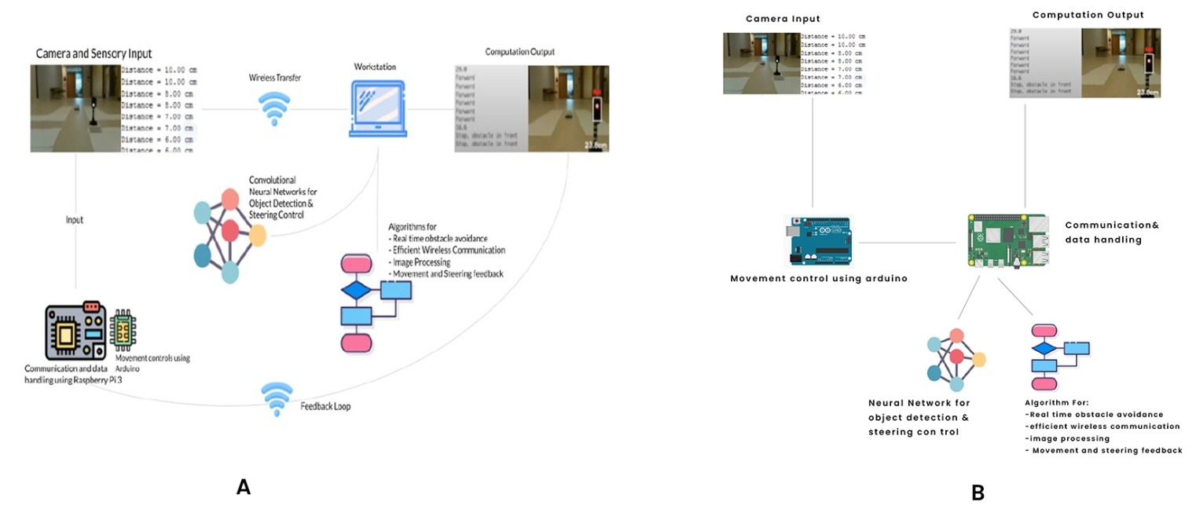

**Figure 4.1 Comparison between Plans**

Plan A – Personal Computer taken as workstation

Plan B – Raspberry Pi taken as workstation

**Table 4.1 Plan A VS Plan B**

PLAN A PLAN B

|  |  |
| --- | --- |
| A separate workstation is required for the purpose of computation. | Raspberry Pi is the workstation. |
| Convergence time is high. | Convergence time is low. |
| Connections are complex. | Connections are quite handy. |
| Workstation always needs to be near the car for the communication to be possible. Hence, PC need to be physically carried while car is in motioin. | Since, workstation is in the car itself no need to physically carry anything. |

**4.2 Stop Sign Detection**

Approach: Positive and negative samples will be collected. These samples will be used for training a Haar Cascade Classifier model. The pictures collected will initially be trimmed and converted to grey Scale. Each picture collected will be of size 360*240 , The size of the picture represents the number of pixels present in the picture, As per the grey scale methodology each pixel will be represented by a number ranging from 0 – 255. The number 0 represents a complete dark shade while number 255 will represent a complete white shade. Therefore, in total there will 256 shades of grey used to represent all the pixel and it will result in a matrix of size 360 *240. Then this matrix will be then converted into a scalar of size 86400. This scalar acts as the input layer of the model.

**Haar Cascade Classifier**

It is an Object Detection Algorithm used for the purpose of identification in an image or a real time video. The algorithm uses edge or line detection features proposed by Viola and Jones in their research paper “Rapid Object Detection using a Boosted Cascade of Simple Features” published in 2001. The algorithm is to be given a lot of positive images consisting of faces, and a lot of negative images not consisting of any face to train on them.

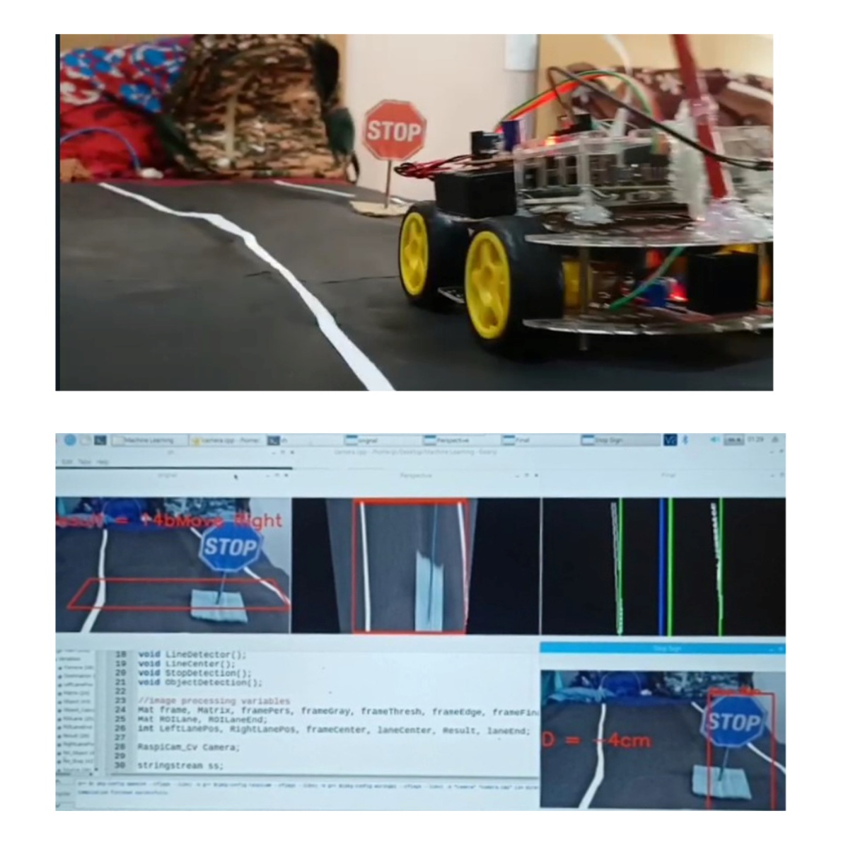

**Figure 4.2 Object detection using image recognition**

**4.3 Lane Detection**

Firstly Raspberry Pi cam capture images in BGR format , so it is converted to bgr format , then half frame is considered and region of interest and perspective wrap is found , perspective wrap image is again converted to BGR format and 2 threshold frequencies i.e white and black is found , so that lane lines are obtained. Then we will do edge detection of our lanes by canny edge detection method which uses hysteresis approach, then we will find lane distances by comparing intensities. We will also calculate lane center which will help car to move left, right, straight.

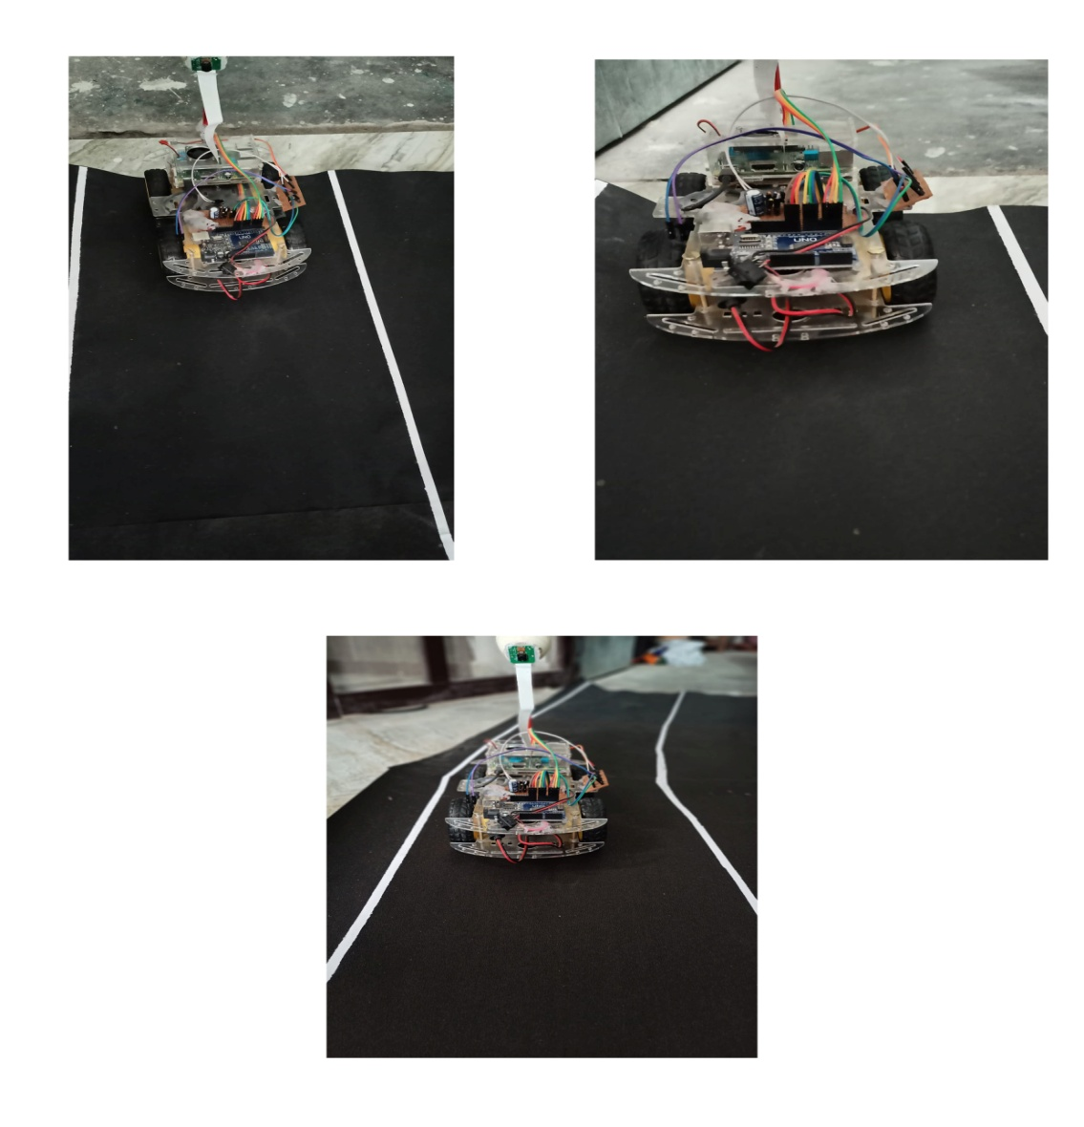

**Figure 4.3 Lane detection using Open CV**

**4.4 Object Distance calculation**

Distance between object and car can be calculated without any sensor like ultrasonic (HCSR04) .For the purpose of measuring distance between car and stop sign, we will be using an algorithm based on 2 linear equation between actual distance measured by ruler and length of stop sign as measured using Open CV.

Distance of 20 cm will be considered as a stopping distance if we want to stop vehicle at 15 cm because inertia of motors will not make car to always stop at accurate distance.

The raspberry pi will send appropriate command to Arduino and stopping time of 5sec is set .

In similar fashion we will try to train our car in traffic light data as well, where red light will make car stop and green will allow car to pass.

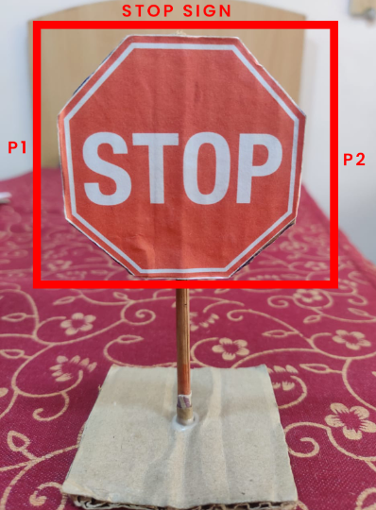

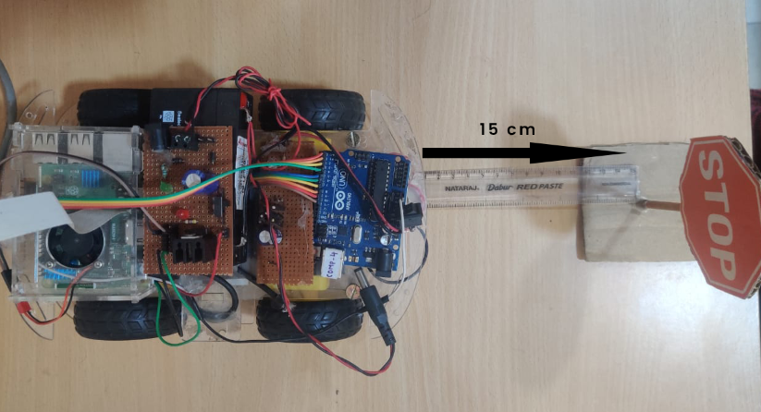

**Figure 4.4 Stop Sign Distance Calculation**

**Chapter 5**

**Conclusions and scope for further work**

This chapter presents the learning we procured from the entire journey of this project. It also throws some light on the future scope of this project.

**5.1 Conclusion**

The advent of the Internet of Things has opened up new opportunities, and when we combine the strengths of IOT with Machine Learning, we can quickly create machines that are more accurate than people. The thought of a self-driving vehicle has long been a pipe dream, but advances in the field of Neural Networks are making it conceivable, albeit much more study is required. Our car's core premise will be to recognize barriers, signs, and other cues in order to make predictions. We want to set the functionality of various chips, technologies, concepts, and so on, and comprehend how a self-driving automobile may work.

A approach for creating a self-driving automobile model is provided in this study by creating a prototype of one. The various hardware components, as well as software and neural network setup, are all readily shown, Image Processing and Machine Learning are used to explain the situation. Learning an effective model was created that operated in line with expectations. Hence, the successful working of this project is entirely based on various components and technologies configured together and working in real which is the real meaning of IOT. As a result, the model was created, tested and implemented successfully.

In the actual world, automotive automation is a huge field. Our plan is to build a prototype that can detect distance and objects like as stop signs, signals, and other barriers using a single monocular vision approach that may be improved in the future an automobile that has been shrunk down to the size of a real car. This is what the prototype focuses on i.e features in a model rc automobile that we are designing. Others concentrate on a single facet of it.

* when the motor draws large amount of current then raspberry pi reboots again and again
* If the camera modules get depositioned or removed entire image processing parameter changes
* We would solve the issue of information on rasberry pi not being sent at high bit rate, so there could be a lag on judgement , which can also lead to accidents etc.
* The car is not able to identify images of signs sometimes
* The distance calculated between obstacle and car is not always 100 % correct.

**5.2 Scope for future work**

* AVs mean a better road and transport infrastructure, city planning, network and wireless connectivity in India
* The Indian automotive industry is one amongst the biggest within the world. It contributes about 7.1% of India’s GDP, and could be a major contributor towards manufacturing, job creation, exports still as foreign inflows.
* Daimler, Uber, General Motors, Tesla, Audi, Ford, Honda, Apple, and BMW are among the major automakers, technology firms, and fleet service providers  investing substantial time and money in the development of autonomous vehicles. Most of them are already conducting trials in the United States, Germany, Singapore, the United Kingdom, Japan, and China. Because of the huge success in these trials  , several of these nations have already passed legislation allowing for testing as well as the operation of AVs.

**What is TESLA doing?**

At this current time Tesla is world's most valuable auto firm and it has opened an office in Bangalore and plans to penetrate the Indian market. The question today is not whether self-driving cars are safe on Indian roads and whether Indian laws are prepared to deal with the challenges that come with them.Tesla claims that their self-driving cars are four times better than normal cars; while in Autopilot mode, there is an estimated 1 fatality per 320 million miles driven.

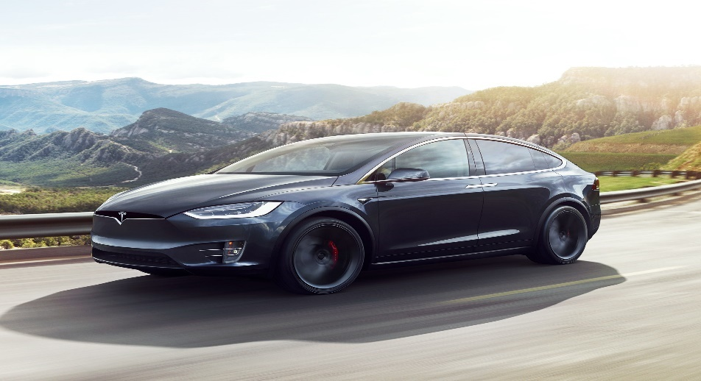

**Figure 5.1 Tesla Mode x [33]**

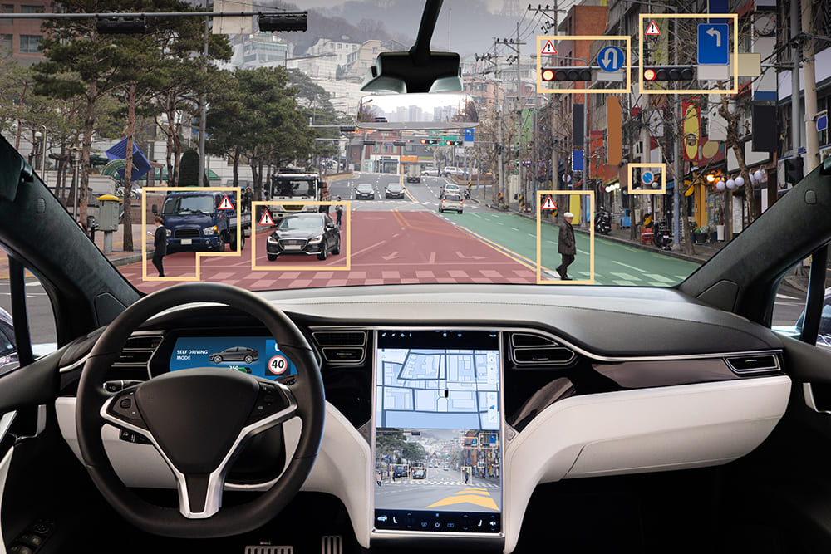

**Figure 5.2 How Tesla Model uses artificial intelligence [34]**

This is how Tesla uses AI

The working of self-driving automobiles (Tesla) , is centered around artificial intelligence (AI). The camera, ultrasonic sensors, and radar mounted to the automobiles provide data to the AI programme. It uses complicated algorithms and a machine learning system to perceive the surroundings around the automobiles. The majority of self-driving vehicles employ 'LiDAR' (light detection and ranging) technology, which uses sensors to fire light pulses from the car's surroundings to calculate distances, recognise road boundaries, and identify lane markers.

**The scope of Self-Driving cars in India:**

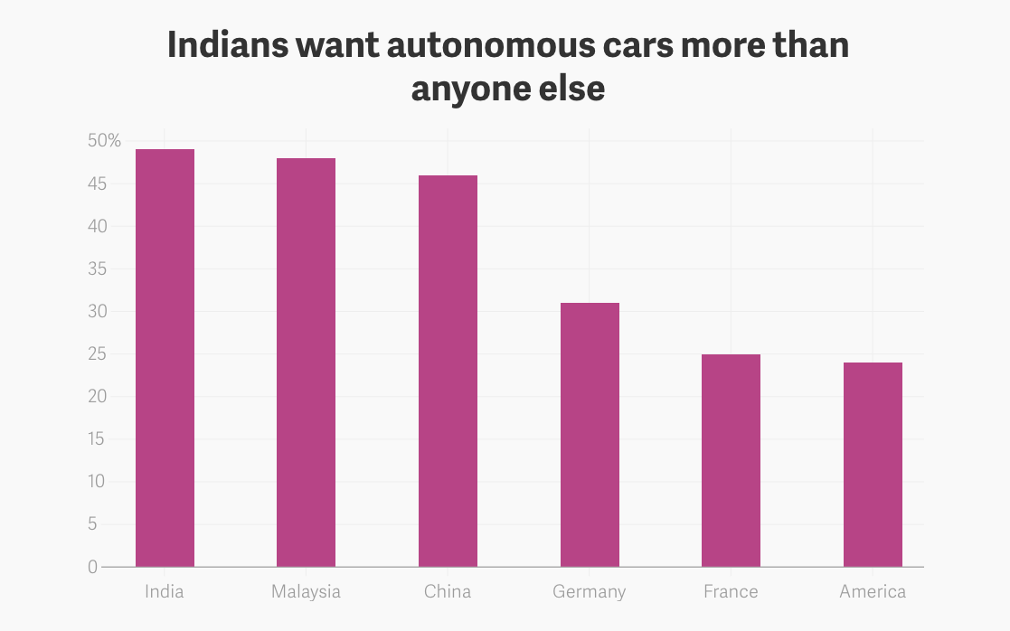

**Figure 5.3 Graph of how much India wants autonomous car [35]**

As you can see, India has the biggest need for autonomous car technology. Traffic jams are common on Indian roadways, which are notorious for being crowded. The number of traffic accidents and deaths caused by them is rapidly increasing. It's reasonable to claim that the many developments in the Internet of Things will pave the road for self-driving automobiles. Ola is one of the most effective new companies in India testing with driverless car technologies. Many startups have arrived who have extensively invested in this technology. Flux Auto, Fisheyebox, Netradyne, Ati Motors, and Swaayatt Robots are some of the self-driving technology startups in India.

**Position in India**

There are many diverse laws and activities in different countries throughout the world. There is currently no special regulation in India to control self-driving automobiles , even the 2019 modification to the Motor Vehicle Act had no effect on self-driving vehicles.

But one of the most pressing questions is whether India should adopt the British model, in which the owner is accountable even if the AI makes a mistake, or the German model, in which the maker of the automobile is liable when the AI makes a mistake..

If reference is drawn from the newly enacted Consumer Protection Act, 2019, under section 2(34) which defines the product liability as “the responsibility of a product manufacturer or product seller, of any product or service, to compensate for any harm caused to a consumer by such defective product manufactured or sold”. So if we consider AI as a product then the manufacturer is totally liable for the damage caused by this.

Since, India is at the top of the world in terms of road accidents, where at least 1.5 lakh people die each year, comprehensive legislation with clear culpability lines is required.**Challenges that AV face in India**

* The Indian government is concerned about the loss of jobs as a result of automation. The government's stance on this problem may be one of the main reasons why global automakers do not consider India as a promising market.
* Another major hurdle for AVs in India is inadequate road and transportation infrastructure, which is responsible for the majority of traffic accidents and deaths in the country.
* These obstacles haven't deterred Indian automakers like Tata, Mahindra, and a slew of other IT entrepreneurs from pursuing AV technology.

**INDIAN STARTUPS IN THE PROTOTYPE PHASE**

**Minus Zero**

There is an Indian startup named Minus Zero which creates self-driving automobiles for Indian highways. This startup is attempting to cut costs by abandoning Lidar in favour of a camera-focused sensor suite. They have created an artificial intelligence that can accurately extract 3D information from a 2D camera picture. Instead of relying on lane markers and sealed roads, they have developed software that maps the route ahead of the car and detects drivable regions.

**Flux Auto**

• A Bangalore-based firm is developing self-driving trucks.

• Flux Auto wants to turn a regular truck into a driverless vehicle.

• It effectively facilitates functions such as lane keeping, cruise control, and collision avoidance.

• Instead of Lidar, the firm is employing vision algorithms with inexpensive cameras with fast reaction rates to make the vehicle as cheap as possible.

|  |
| --- |
| **Bibliography**   1. [**https://www.freepik.com/search?format=search&query=iot**](https://www.freepik.com/search?format=search&query=iot) 2. [**https://www.viatech.com/en/2019/06/the-benefits-of-self-driving-cars/**](https://www.viatech.com/en/2019/06/the-benefits-of-self-driving-cars/) 3. [**https://www.researchgate.net/publication/346527331_The_Future_of_Autonomous_Vehicles**](https://www.researchgate.net/publication/346527331_The_Future_of_Autonomous_Vehicles) 4. [**https://fisheyebox.wordpress.com/2018/04/26/how-self-driving-cars-work/**](https://fisheyebox.wordpress.com/2018/04/26/how-self-driving-cars-work/) 5. [**https://www.freepik.com/search?format=search&query=self%20driving%20car**](https://www.freepik.com/search?format=search&query=self%20driving%20car) 6. [**https://en.wikipedia.org/wiki/History_of_self-driving_cars**](https://en.wikipedia.org/wiki/History_of_self-driving_cars) 7. [**https://en.wikipedia.org/wiki/General_Motors_Firebird#/media/File:General_Motors_exhibit_at_Century_21_Exposition,_1962.jpg**](https://en.wikipedia.org/wiki/General_Motors_Firebird#/media/File:General_Motors_exhibit_at_Century_21_Exposition,_1962.jpg) 8. [**https://assets.publishing.service.gov.uk/government/uploads/system/uploads/attachment_data/file/401562/pathway-driverless-cars-summary.pdf**](https://assets.publishing.service.gov.uk/government/uploads/system/uploads/attachment_data/file/401562/pathway-driverless-cars-summary.pdf) 9. [**http://www-di.inf.puc-rio.br/~endler/students/ProjetosFinais/MarcPaulon-Proposta.pdf**](http://www-di.inf.puc-rio.br/~endler/students/ProjetosFinais/MarcPaulon-Proposta.pdf) 10. [**https://www.researchgate.net/publication/339096649_Real_Time_Ackerman_Steering_Angle_Control_for_Self-Driving_Car_Autonomous_Navigation#pf2**](https://www.researchgate.net/publication/339096649_Real_Time_Ackerman_Steering_Angle_Control_for_Self-Driving_Car_Autonomous_Navigation%23pf2) 11. [**http://www.homepages.ucl.ac.uk/~zceeg99/imagepro/three.pdf**](http://www.homepages.ucl.ac.uk/~zceeg99/imagepro/three.pdf) 12. Wang, Chun-Che, Shih-Shinh Huang, and Li-Chen Fu. "Driver assistance system for lane detection and vehicle recognition with night vision." Intelligent Robots and Systems, 2005.(IROS 2005). 2005 IEEE/RSJ International Conference on. IEEE, 2005. 13. Miao, Xiaodong, Shunming Li, and Huan Shen. "ON-BOARD LANE DETECTION SYSTEM FOR INTELLIGENT VEHICLE BASED ON MONOCULAR VISION." International Journal on Smart Sensing & Intelligent Systems 5.4 (2012). 14. Saha, Anik, et al. "Automated road lane detection for intelligent vehicles." Global Journal of Computer Science and Technology (2012). 15. Pannu, Gurjashan Singh, Mohammad Dawud Ansari, and Pritha Gupta. "Design and implementation of autonomous car using Raspberry Pi." International Journal of Computer Applications 113.9 (2015) 16. Mohanapriya, R., Hema, L. K., Yadav, D., & Verma, V. K. (2014). Driverless Intelligent Vehicle for Future Public Transport Based On GPS. International Journal of Advanced Research in Electrical, Electronics and Instrumentation Engineering, 3. 17. Ms. D.D Jadhav.,Komal Jadhav,Kajal Shinde,Anjali Sonawane, , , , ."Autonomous Vehicle with Obstacle Avoidance and Tracking", Volume 4, Issue VIII, International Journal for Research in Applied Science and Engineering Technology(IJRASET). 18. Dhanasingaraja, R., S. Kalaimagal, and G. Muralidharan. "Autonomous Vehicle Navigation and Mapping System." Division of Mechatronics, 2014 International Conference on Innovations in Engineering and Technology. Vol. 3. No. 3. 2014. 19. Truong-Dong Do, Minh-Thien Duong, Quoc-Vu Dang and My-Ha Le, “Real Time Self-Driving Car Navigation Using Deep Neural Network” in International Conference on Green Technology and Sustainable Development (GTSD), 2018. 20. Hajer Omrane, Mohamed Slim Masmoudi and Mohamed Masmoudi, “Neural controller of autonomous driving mobile robot by an embedded camera” in International Conference on Advanced Technologies For Signal and Image Processing - ATSIP, 2018. 21. Abdur R. Fayjie, Sabir Hossain, Doukhi Oualid, and Deok-Jin Lee, “Driverless Car: Autonomous Driving Using Deep Reinforcement Learning In Urban Environment” in 15th International Conference on Ubiquitous Robots (UR) Hawaii Convention Center, Hawai'i, USA, June 27-30, 2018. 22. [**http://wiki.sunfounder.cc/index.php?title=Motor_Driver_Module-L298N**](http://wiki.sunfounder.cc/index.php?title=Motor_Driver_Module-L298N) 23. [**http://wiki.sunfounder.cc/index.php?title=Motor_Driver_Module-L298N**](http://wiki.sunfounder.cc/index.php?title=Motor_Driver_Module-L298N) 24. [**https://acoptex.com/project/162/basics-project-033a-l298n-dual-h-bridge-motor-driver-module-one-or-two-dc-motors-6v-at-lex-c/**](https://acoptex.com/project/162/basics-project-033a-l298n-dual-h-bridge-motor-driver-module-one-or-two-dc-motors-6v-at-lex-c/) 25. [**https://www.pinterest.com/pin/541206080218245335/?amp_client_id=CLIENT_ID(_)&mweb_unauth_id={{default.session}}&simplified=true**](https://www.pinterest.com/pin/541206080218245335/?amp_client_id=CLIENT_ID(_)&mweb_unauth_id=%7b%7bdefault.session%7d%7d&simplified=true) 26. [**https://roboticsbackend.com/raspberry-pi-arduino-serial-communication/**](https://roboticsbackend.com/raspberry-pi-arduino-serial-communication/) 27. [**https://www.jameco.com/Jameco/workshop/circuitnotes/raspberry-pi-circuit-note.html**](https://www.jameco.com/Jameco/workshop/circuitnotes/raspberry-pi-circuit-note.html) 28. [**https://www.ibm.com/cloud/blog/ai-vs-machine-learning-vs-deep-learning-vs-neural-networks**](https://www.ibm.com/cloud/blog/ai-vs-machine-learning-vs-deep-learning-vs-neural-networks) 29. [**https://riptutorial.com/machine-learning/example/31624/activation-functions**](https://riptutorial.com/machine-learning/example/31624/activation-functions) 30. [**https://medium.com/@curiousily/tensorflow-for-hackers-part-iv-neural-network-from-scratch-1a4f504dfa8**](https://medium.com/@curiousily/tensorflow-for-hackers-part-iv-neural-network-from-scratch-1a4f504dfa8) 31. [**https://www.researchgate.net/figure/Region-of-interest-section_fig1_308852371**](https://www.researchgate.net/figure/Region-of-interest-section_fig1_308852371) 32. [**https://www.javatpoint.com/opencv-canny-edge-detection**](https://www.javatpoint.com/opencv-canny-edge-detection) 33. [**https://www.tesla.com/modelx**](https://www.tesla.com/modelx) 34. [**https://bernardmarr.com/how-tesla-is-using-artificial-intelligence-to-create-the-autonomous-cars-of-the-future/**](https://bernardmarr.com/how-tesla-is-using-artificial-intelligence-to-create-the-autonomous-cars-of-the-future/) 35. [**https://medium.com/@UdacityINDIA/scope-of-self-driving-cars-in-india-5dff321436b**](https://medium.com/@UdacityINDIA/scope-of-self-driving-cars-in-india-5dff321436b)       **Acknowledgement**  We would like to express our gratitude to K.J. Somaiya College of Engineering for giving us this opportunity to work on this project. We would like to thank our guide Dr. SANDEEP SAINKAR for allowing us to perform the project and helping and guiding us to select the related topics and projects. We would also like to thank Principal Dr. SHUBHA PANDIT for creating such opportunities. Every member of our group has tried to learn various concepts required for successful implementation and completion of this project |